SOFTWARE DEVELOPMENT PROPOSAL

PREPARED FOR
AI-assisted OSLP

PREPARED BY
Jalaluddin, Hetal, Zhengqun
JHZ Pte. Ltd

PROJECT NAME | AI-assisted Online Shopping for Luxury Products
EST. START DATE | 01 March 2025 | EST. FINISH DATE | 30 May 2026
SUBMITTED TO | Faizal | COMPANY | OSLP Pte. Ltd
CONTACT NAME | Faizal Yusuf | ADDRESS | 123 Somerset Road, #05-321 Singapore 238165
PHONE | 85858585 | ADDRESS | 123 Somerset Road, #05-321 Singapore 238165
EMAIL | faizalyusuf@contact.com | ADDRESS | 123 Somerset Road, #05-321 Singapore 238165

SUBMITTED BY | Jalal, Hetal, Zhengqun | COMPANY | JHZ Pte. Ltd
CONTACT NAME | Jalal | ADDRESS | 77 Raffles Place, #16-00 Singapore 048623
PHONE | 99998888 | ADDRESS | 77 Raffles Place, #16-00 Singapore 048623
EMAIL | contact@aioslp.com | ADDRESS | 77 Raffles Place, #16-00 Singapore 048623

PROJECT OVERVIEW Jalal
This project proposes a strategic enhancement of the AI-assisted Online Shopping for Luxury Products (OSLP) platform through the adoption of a modular, cloud-native PaaS architecture on Microsoft Azure. Rather than a high-risk overhaul, the goal is to implement a phased modernization that addresses critical gaps in customer exclusivity and operational efficiency that have hindered the platform's ability to retain high-net-worth clients. Challenges such as the "dilution" of the luxury brand identity online, disconnected omnichannel inventory, and the inability to scale personalized "white-glove" service have not only affected customer satisfaction but also threatened the brand's perceived value in an uncertain market.
The enhanced solution will introduce a cost-effective, auto-scaling Azure App Service infrastructure to ensure system stability, along with AI-powered "Virtual Advisors" to democratize the VIP concierge experience. Crucially, a streamlined Admin Interface will be developed to empower shopkeepers with real-time insights and AI-assisted workflows, ensuring the backend operations are as seamless as the customer journey. By transitioning to this transparent, secure, and modular architecture, the platform aims to deliver a seamless, efficient, and highly personalized shopping experience that aligns with the elevated expectations of luxury clientele and positions the business for sustainable growth.

PURPOSE / GOALS Jalal
This project aims to transform the luxury retail experience by implementing an AI-assisted Online Shopping for Luxury Products (OSLP) platform. The initiative addresses the current industry slowdown and customer dissatisfaction by leveraging a risk-aware, phased cloud modernization strategy that balances high-end service expectations with financial and technical feasibility.
1. Elevate Customer Experience with "White-Glove" Personalization
- Deploy Azure OpenAI Services to create a "Virtual Advisor" that provides hyper-personalized, human-like assistance and transparently labeled AI dialogue.
- Bridge the gap between digital and physical channels (omnichannel) to ensure seamless transitions for high-net-worth clients.
- Enhance item discovery and recommendation accuracy to match the exclusivity expected in the luxury sector.
2. Ensure Feasible and Scalable Infrastructure (Risk Mitigation)
- Adopt a "Phase 1" PaaS (Platform as a Service) approach using a Modular Monolith hosted on Azure App Service to minimize initial setup risks and costs (addressing the $1M barrier).
- Prioritize a gradual implementation strategy over immediate full Kubernetes (AKS) deployment to simplify maintenance for smaller DevOps teams while retaining the ability to scale vertically and horizontally.
- Utilize Azure Front Door for global load balancing and performance optimization to handle traffic without server overload.
3. Empower Backend Operations and Shopkeepers
- Extend the AI solution to support backend users—specifically shopkeepers—by providing real-time client insights and automated communication drafts.
- Design and implement intuitive Admin Area interfaces to ensure the solution improves operational workflows, not just customer-facing interactions.
- Integrate a centralized Order Management System (OMS) to act as a single source of truth for inventory, facilitating "Click & Collect" and "Ship from Store" strategies.
4. Strengthen Security and Brand Trust
- Implement Azure AD B2C for secure customer authentication and Azure Key Vault for encryption to protect sensitive high-value client data.
- Ensure pricing transparency and trust through specific APIs, mitigating the risk of "AI distrust" by clearly labeling automated interactions.
- Replace high-cost hardware security modules (HSM) with cost-effective, compliant cloud-native security measures where appropriate to optimize the budget while maintaining PCI compliance.
5. Future-Proof the Brand Against Market Uncertainty
- Counter the projected luxury industry growth slowdown (1-3%) by differentiating the brand through superior digital service.
- Establish a flexible technical foundation that allows for "Phase 2" expansion into microservices as the platform matures and ROI is proven.
- Drive long-term customer loyalty by offering an "always-available" service that maintains the luxury "human touch" in a virtual environment.

OBSTACLES (IF ANY) Jalal
INCLUDE SOLUTIONS TO THE PROBLEM
When implementing this project, several challenges may arise that could impact its timely delivery, cost-efficiency, and overall effectiveness. Key obstacles include:
- Operational Complexity of Microservices Architecture
Launching with a full Azure Kubernetes Service (AKS) architecture from Day 1 creates a high maintenance burden. For a small DevOps team, managing the complexity of microservices immediately—rather than starting with a Modular Monolith on Azure App Service—poses a risk to system stability and maintainability.
- Backend User Experience and Adoption Gaps
The current solution focuses heavily on the customer ("Virtual Client") while potentially neglecting the "Shopkeeper" (backend administrator). If the AI system lacks a well-designed Admin Interface or fails to simplify workflows for internal staff, it risks poor adoption rates and operational inefficiencies.
- Excessive Security Infrastructure Costs
The inclusion of enterprise-grade hardware components, such as Azure Payment HSM, may be cost-prohibitive for the initial rollout. Over-engineering the security layer in Phase 1 could inflate the budget unnecessarily compared to using standard, compliant cloud encryption methods.
- Data Privacy and Compliance Risks
Handling sensitive data for high-net-worth luxury clients requires strict adherence to data protection regulations (PDPA) and payment standards (PCI DSS). Any breach or compliance failure would result in severe reputational damage to the brand's image of exclusivity and trust.

INDUSTRY / MARKET RISK FACTORS Jalal
Highlighting and minimizing the following risks and industry factors towards customer behavior and competitive market expectations, making them critical to address;
- User Trust (AI Distrust)
A key market risk, as customer adoption and loyalty depend on confidence in AI-assisted services. Widespread skepticism toward AI can directly impact brand perception and competitive positioning.
- Traffic & Performance Expectations
High market demand for always-available, fast digital services creates risk if performance does not meet industry standards. Poor scalability can result in customer churn and loss of market share.
- Data Privacy & Regulatory Compliance
Industry-wide risk driven by strict data protection regulations and rising customer expectations around privacy. Any failure can lead to legal penalties, reputational damage, and loss of trust.
- Cyber Attacks
A significant industry risk affecting all digital commerce platforms. Increasing sophistication of cyber threats can disrupt services, compromise customer data, and negatively impact brand credibility.
- AI Misuse (Lower Impact Market Risk)
While lower in impact, misuse of AI can still affect public perception and compliance expectations across the industry, especially as regulatory scrutiny around AI continues to grow.
BUDGETARY ASSUMPTIONS Zhengqun
SOFTWARE EMPLOYED Hetal
The proposed AI-assisted Online Shopping for Luxury Products (OSLP) platform will be built on a cloud-native architecture hosted on Microsoft Azure. All hardware resources are virtualized and delivered as managed cloud services, providing high availability, elasticity, and enterprise-grade security suitable for luxury retail operations.
The software stack is designed to support AI-driven personalization, omnichannel integration, secure transactions, and high-performance user experiences, while maintaining transparency and compliance with data protection and payment security standards.
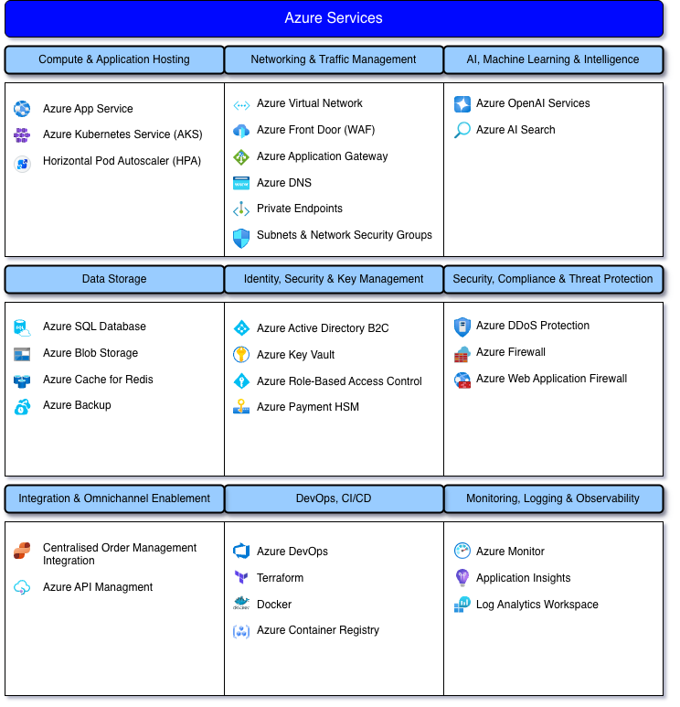

Architecture Diagram Hetal
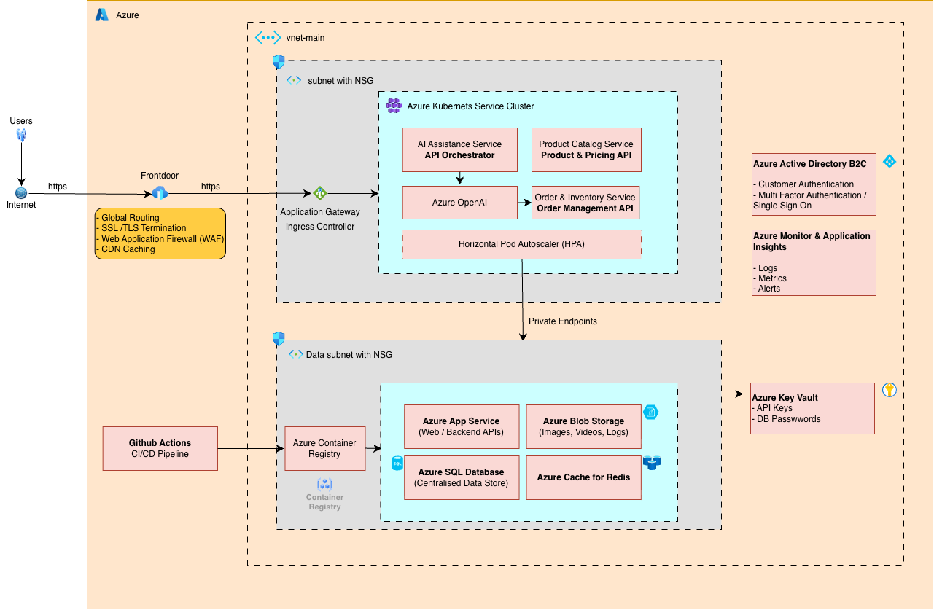

Architecture Overview and Phased Deployment Strategy
The architecture diagram above represents the target-state cloud architecture for the AI-assisted Online Shopping for Luxury Products (OSLP) platform. It is designed to support enterprise-grade scalability, security, and AI-driven personalization while maintaining long-term operational resilience.
To reduce cost and operational risk, the solution follows a phased architecture strategy rather than adopting full container orchestration from day one.
Phase 1 – Modular Monolith (PaaS-First Deployment)
In Phase 1, the platform is deployed as a modular monolith on Azure App Service (PaaS). Core capabilities—including AI concierge, product catalog, order processing, payments, and admin management—are implemented as internal modules within a single application.
Azure App Service provides built-in scaling, SSL termination, automated patching, and high availability, enabling rapid delivery with minimal DevOps overhead. Supporting services such as Azure SQL Database, Azure Blob Storage, Azure OpenAI Services, Azure AI Search, and Azure Front Door with Web Application Firewall (WAF) are used as shown in the target architecture, ensuring consistency while keeping early-stage complexity low.
Phase 2 – Scalable Enterprise Architecture (Target State)
As platform adoption and transaction volume grow, the system evolves into the target architecture illustrated in the diagram. Application components are containerized and deployed on Azure Kubernetes Service (AKS), enabling independent scaling of AI services, product APIs, and backend integrations. Traffic is securely routed via Application Gateway Ingress, while Horizontal Pod Autoscaling supports peak demand such as exclusive product launches.
Private endpoints connect application services to backend resources, including Azure SQL Database, Azure Cache for Redis, and Azure Blob Storage, preventing public internet exposure and enhancing security.
Security, AI, and Backend Users
AI-driven personalization and conversational assistance are delivered through Azure OpenAI Services and Azure AI Search. Authentication and role-based access are managed using Azure Active Directory B2C, while secrets and encryption keys are stored in Azure Key Vault. Azure Payment HSM is included as an optional future enhancement; Phase 1 relies on Key Vault–managed keys to control cost.
The architecture also supports backend users through a secure Admin Portal, enabling inventory management, pricing updates, order handling, and AI-assisted sales insights for shop managers and advisors.
System Architecture Description
User and Internet Entry Point | ● Customers: Access the OSLP platform via web or mobile interfaces to receive AI-assisted product discovery, personalised recommendations, and seamless luxury shopping experiences.  ● Shop Administrators: Access a secure backend interface to manage inventory, pricing, orders, and gain AI-driven customer insights.  ● Internet: Serves as the secure access channel enabling omnichannel engagement across global luxury markets.
Azure Front Door and CDN | ● Provides a secure and performant global entry point for OSLP users.  ● Delivers business value by:  Protecting brand reputation through bot mitigation and web application firewall (WAF) controls, improving customer experience with low-latency content delivery for rich product imagery and media, and ensuring secure transactions via SSL termination.
Application Hosting Platform (Phased Architecture) | ● Azure Kubernetes Service (AKS): Hosts containerized OSLP application pods, including:  ▪ oslp-web (Frontend Pod): Serves the customer-facing luxury storefront and admin interface; first internal service reached after ingress.  ▪ oslp-ai (AI Advisor Pod): Handles AI-assisted conversations, personalised recommendations, and advisor support using Azure OpenAI.  ▪ oslp-core (Commerce API Pod): Manages product catalog, pricing, inventory visibility, and order processing; communicates with Azure SQL and Redis via private endpoints.  ▪ secret-provider (CSI Pod): Securely mounts secrets from Azure Key Vault into application pods, preventing hard-coded credentials.  ● Application Gateway Ingress Controller: Terminates HTTPS, routes requests to the correct application pod, and load-balances traffic across replicas.  ● Horizontal Pod Autoscaler (HPA): Scales pod replicas based on demand to maintain performance during high-traffic shopping periods.
Networking and Secure Connectivity | ● Azure Virtual Network (VNet):  ▪ Separates application services and data services to limit access to sensitive customer, transaction, and inventory data used by the OSLP platform.  ● Private Endpoints:  ▪ Azure SQL Database: Protects customer profiles, order records, and boutique operational data.  ▪ Azure Cache for Redis: Secures user sessions and AI conversation context.  ▪ Azure Blob Storage and Azure Key Vault: Prevents public access to product media, logs, and encryption secrets.  ● Network Security Groups (NSGs):  ▪ Restrict traffic between subnets to only required application flows.
Data and Platform Services | ● Azure SQL Database:  ▪ Stores transactional data such as customer accounts, orders, inventory levels, and administrative records.  ● Azure Cache for Redis:  ▪ Improves response times for product queries, pricing lookups, and AI-assisted interactions.  ● Azure Blob Storage:  ▪ Stores high-resolution luxury product images, digital assets, and system logs required for platform operations.
Identity, Security, and Governance | ● Azure Active Directory B2C:  ▪ Manages authentication for customers, boutique advisors, and administrators with role-based access.  ● Azure Key Vault:  ▪ Stores database credentials, API keys, and Azure OpenAI access tokens used by OSLP services.  ● Role-Based Access Control (RBAC):  ▪ Ensures backend users only access functions relevant to their responsibilities, such as inventory or order management.
DevOps, Monitoring, and Security | ● Azure DevOps Pipelines:  ▪ Automates build, test, and deployment of OSLP application components.  ● Azure Container Registry (ACR):  ▪ Stores versioned application images deployed to the hosting platform.  ● Azure Monitor and Log Analytics:  ▪ Tracks application health, API response times, and system errors for operational visibility.  ● Audit Logs and Alerts:  ▪ Record access and system activity to support troubleshooting and compliance reviews.

DEPLOYMENT / DISTRIBUTION Hetal
The purpose of this deployment and distribution strategy is to ensure that the AI-assisted Online Shopping for Luxury Products (OSLP) platform is delivered in a secure, scalable, and carefully managed way that minimizes risks and ensures stability throughout the release process. This strategy aligns with established cloud deployment practices, DevOps lifecycle models, and operational standards commonly used in enterprise-grade applications.
- Pre-Deployment Preparation
  - Finalization of architecture, security policies, and deployment configurations in alignment with ISO/ITIL-inspired change and release management principles
  - Validation of infrastructure readiness, including networking, access controls, monitoring, and alerting tools
  - Completion of documentation, deployment checklists, and rollback procedures to support operational stability
- Staging Environment Deployment
  - All platform components (frontend, backend services, AI modules, databases) will first be deployed to a staging environment that mirrors production
  - Internal functional, performance, and security testing will be conducted as part of the DevOps continuous testing lifecycle
  - AI personalization logic and recommendation accuracy will be validated before production release
- User Acceptance Testing (UAT)
  - Selected stakeholders, boutique advisors, and test users will validate real-world usage scenarios
  - Feedback will be reviewed and necessary refinements applied
  - Formal approval will be required before production deployment
- Production Deployment
  - Deployment to the live environment will be executed in a controlled, incremental manner
  - Monitoring and observability tools will track system health, traffic, and performance in real time, supporting SRE reliability objectives
- Post-Deployment Monitoring and Optimization
  - Continuous monitoring of application performance, AI behavior, and security events
  - Fine-tuning of AI recommendations and system configurations based on user behavior and operational metrics
  - Rapid rollback and incident response mechanisms will be available if critical issues are detected, supporting service continuity
TESTING Hetal
Testing will be conducted throughout the development and deployment lifecycle, using a combination of automated and manual testing approaches. Each testing phase is designed to validate specific aspects of the platform.

- Unit Testing
  - Validate core business logic such as pricing calculations, cart totals, order status, and inventory rules.
  - Test AI prompt logic, guardrails, and response formatting in isolation.
  - Verify input validation and error handling for invalid data and edge cases.
- API & Integration Testing
  - Test frontend–backend APIs for product listing, search, cart, checkout, and user accounts.
  - Validate authentication and authorization (customer vs admin access).
  - Verify correct data flow between services, databases, and external systems.
- Payment Gateway Testing
  - Test end-to-end payment flow using sandbox mode (authorize, capture, success/failure handling).
  - Validate edge cases such as declined cards, timeouts, duplicate submissions, and retries.
  - Confirm secure handling of payment data, tokenization, and refund/void processes.
- AI Recommendation & Concierge Testing
  - Validate relevance and accuracy of AI recommendations across defined shopping scenarios.
  - Ensure AI tone is polite, professional, and consistent with luxury brand guidelines.
  - Confirm AI responses are grounded in actual catalog data and stock availability.
- Functional End-to-End Testing
  - Validate complete customer journey from browsing to checkout and order confirmation.
  - Test user account features such as wishlists, order tracking, and returns.
  - Verify admin and boutique workflows including inventory updates and assisted checkout.
- Performance, Load & Scalability Testing
  - Simulate high traffic during exclusive drops and seasonal sales.
  - Validate auto-scaling and load balancing behavior under peak demand.
  - Identify performance bottlenecks in search, images, AI responses, and checkout.
- Security Testing
  - Test protection against common web vulnerabilities and misconfigurations.
  - Validate access controls, bot protection, and rate limiting mechanisms.
  - Verify audit logging, monitoring alerts, and incident detection.
- Compatibility & Device Testing
  - Test across major browsers and devices (mobile, tablet, desktop).
  - Validate boutique tablet and POS integration workflows.
  - Ensure consistent UI behavior, accessibility basics, and localization.
- User Acceptance Testing (UAT)
  - Run real-world scenarios with stakeholders and boutique advisors.
  - Validate usability, performance, and luxury service expectations.
  - Obtain formal approval before production deployment.
- Regression Testing
  - Run automated regression tests after each release via CI/CD pipelines.
  - Ensure new changes do not break existing core features.
  - Validate rollback readiness and release stability.

DOCUMENTATION Hetal
Documentation will be created and maintained throughout the development, testing, deployment, and post-launch phases. All documents will be version-controlled and updated as the platform evolves.
1. System and Architecture Documentation
Purpose: Provide a clear technical overview of the platform design and component interactions.
Deliverables:
- System Architecture Document – High-level diagrams showing frontend, backend services, AI components, databases, and integrations.
- Cloud Infrastructure Diagram – Azure resource layout including networking, security boundaries, and service dependencies.
- Component Interaction Description – Explanation of how AI services, application services, and databases communicate.
2. Development Documentation
Purpose: Support developers in building, maintaining, and extending the platform.
Deliverables:
- Code Documentation – Inline comments and README files for each service or module.
- Environment Setup Guide – Instructions for local development and testing environments.
- Configuration Reference – Description of key application settings and environment variables.
3. Testing Documentation
Purpose: Ensure transparency and traceability of quality assurance activities.
Deliverables:
- Test Plan – Scope, objectives, and test types (functional, performance, security, AI testing).
- Test Cases and Scripts – Documented scenarios for core features such as checkout, AI recommendations, and payments.
- Defect and Test Reports – Bug descriptions, severity classification, and resolution status.
4. Deployment and CI/CD Documentation
Purpose: Ensure smooth releases and long-term operational transparency.
Deliverables:
- CI/CD Pipeline Documentation – Explanation of build, test, and deployment workflows, including rollback procedures.
- Deployment Guide – Step-by-step instructions for deploying to staging and production environments.
- Deployment Checklist – Pre-release verification items such as configuration, secrets, DNS, SSL, and monitoring readiness.
- Release Notes – Summary of features, fixes, and changes included in each deployment.
5. Operations and Monitoring Documentation
Purpose: Support day-to-day system operations and incident management.
Deliverables:
- Operations Runbook – Routine operational tasks, system health checks, and maintenance activities.
- Monitoring and Alerting Guide – Metrics tracked, alert thresholds, and response actions.
- Incident Response Playbook – Escalation paths, rollback procedures, and recovery steps.
6. Security and Compliance Documentation
Purpose: Demonstrate secure system design and compliance readiness.
Deliverables:
- Security Architecture Overview – Authentication, authorization, and access control flows.
- Data Protection Policy – Encryption, key management, and data handling practices.
- Audit and Compliance Records – Logging strategy, access audit trails, and security review evidence.
7. User and Administrator Documentation
Purpose: Enable effective use of the platform by customers, administrators, and boutique staff.
Deliverables:
- User Guide – Instructions for browsing products, using AI assistance, checkout, and account management.
- Admin and Boutique Staff Manual – Inventory management, order handling, and assisted sales workflows.
- Troubleshooting Guide – Common issues, error explanations, and resolution steps.
SUPPORT
Following the official launch of the AI-assisted OSLP platform, support will be provided for a period of six months, in accordance with the terms outlined in the service contract. The support model is designed to ensure stability, security, and responsiveness during the transition and adoption period.

1. Customer Support
A dedicated support channel will be established for handling technical queries, incidents, or guidance requests.
Channels include:
- Email support (support@oslp.ai)
- Priority line for urgent operational issues (24/7 for P1 incidents)
- Secure in-app messaging service for rapid consultation during business hours
2. Technical Documentation Access
Client will have full access to comprehensive system documentation, including:
- Architecture diagrams and phased deployment topology
- Admin and operations manuals
- CI/CD runbooks and environment configuration
- Recovery and rollback procedures for PaaS services
3. Scheduled Check-ins
Quarterly review meetings will be conducted to:
- Gather user feedback (Admin and Customer perspectives)
- Assess system performance, AI effectiveness, and reliability
- Apply non-critical tweaks or updates based on evolving business needs
4. Automation & Maintenance
Key operations will be automated to ensure system health and resilience:
- Scheduled security patching and Azure service updates
- Regular automated backups of application data (Azure SQL) and configurations
- Monitoring alerts for uptime, load spikes (App Service), and security anomalies
5. Escalation and Resolution
- A defined incident response plan with clear severity levels and response SLAs will be shared as part of onboarding.
- SLA: High-priority issues (P1: system downtime, data corruption) will be addressed with expedited escalation to the senior technical team with a maximum 2-hour response time.
TRAINING Jalal
REWRITE training for customer to learn how to use the website and it’s AI.
Given the critical feedback regarding the initial proposal's high cost and architectural complexity, structured training and a "Pivot Sprint" will be conducted to realign the technical strategy. The goal is to equip the project team with the skills to transition from a Kubernetes-heavy design to a pragmatic Azure PaaS model, while ensuring the backend "shopkeeper" experience is fully addressed. Training will begin immediately to ensure the Final Proposal meets the new strategic requirements.
Training Duration: 5 Days (Intensive Project Pivot Sprint)
Mode of Delivery: Live instructor-led workshops (virtual), with whiteboard sessions, Azure labs, and design reviews provided for reference.
Training Modules Covered:
Day 1 – Architecture Realignment (PaaS vs. K8s)
- Introduction to Modular Monolith architecture on Azure App Service.
- Moving away from Azure Kubernetes Service (AKS) to reduce operational overhead. (In the future)
- Utilizing Azure Deployment Slots for zero-downtime updates without complex orchestration.
- Redesigning the "Architecture Overview" for the final proposal.
Day 2 – Cost & Security Optimization
- Security vs. Cost Analysis: Replacing Azure Payment HSM with Azure Key Vault (Standard/Premium).
- Offloading PCI-DSS compliance complexity to payment gateways.
- Re-calculating financial estimates to lower the SGD 1.1M budget for better stakeholder buy-in.
- Drafting the revised "Financial Estimates" table.
Day 3 – Operational UX (The "Shopkeeper" Perspective)
- Designing for the Backend User: Creating workflows for the human store administrator.
- Human-in-the-Loop: Interfaces for approving AI-drafted client communications.
- Inventory Management UI: Visualizing "Smart Inventory" insights for store managers.
- Wireframing the "Admin Command Center" for the Final Proposal.
Day 4 – Phased Implementation Strategy
- Adopting the "Strangler Fig" pattern for gradual system modernization.
- Redefining "Phase 1" as a low-risk PaaS Pilot rather than a full cloud migration.
- Structuring the roadmap to prioritize "Quick Wins" (e.g., Pricing API, Bot Protection).
- Rewriting the "High Level Implementation Plan."
Day 5 – Synthesis & Final Proposal Drafting
- Integrating the "Luxury" narrative with the new pragmatic technical approach.
- Finalizing the Executive Summary to reflect the optimized cost-benefit ratio.
- Conducting a final compliance check against the stakeholder feedback checklist.
- Preparation of the final submission document.
Additional Training Support
- Design Templates: UI kits for sketching the Admin Command Center will be provided.
- Recordings: Each workshop session will be recorded and shared for the team's reference.
- Direct Coaching: Access to a Cloud Solutions Architect for reviewing the new Azure architecture diagrams.
COST STRUCTURE (PRELIMINARY)
OVERVIEW | The project will be executed using an Agile methodology across two distinct architectural phases (PaaS-First Modular Monolith in Phase 1, moving to AKS Microservices in Phase 2) to ensure a controlled approach to risk, cost, and complexity. The total projected timeline is 15 months.
NEEDS / INVESTMENT |  |  |  | COST
Agile development and engineering hours for the Modular Monolith on Azure App Service, API development, and Admin Area interfaces. |  |  |  | $550,000 - $650,000
Estimated annual cost for key Azure services (App Service, Azure Front Door, Azure AD B2C, Azure Key Vault, initial Azure OpenAI consumption, storage, and networking). |  |  |  | $150,000 - $200,000
Initial security hardening, compliance consultancy (PDPA, PCI DSS), and implementation of cloud-native security measures to replace cost-prohibitive hardware solutions (e.g., Azure Payment HSM). |  |  |  | $100,000 - $150,000
Project governance, quality assurance, user acceptance testing (UAT), and deployment management. |  |  |  | $80,000 - $100,000
Unforeseen technical issues, minor scope adjustments, and market-related risk mitigation. |  |  |  | 10% of Total Project Cost
ESTIMATE TOTAL |  |  |  | $968,000 - $1,210,000
PAYMENT TERMS
Invoices will be submitted upon the formal sign-off of each milestone by the Client (Faizal Yusuf).
All invoices are payable within thirty (30) days of the invoice date.

Payment shall be made by OSLP Pte. Ltd. to JHZ Pte. Ltd. based on the achievement of the following key project milestones:
MILESTONE | DESCRIPTION | PAYMENT PERCENTAGE | PAYMENT AMOUNT (PRELIMINARY)
M1: Project Initiation & Setup (Month 1) | Upon signing of the contract and formal commencement of the project (includes detailed planning and infrastructure provisioning). | 20% | $190,000
M2: Core Architecture Completion (Month 2 - 7) | Completion of the Modular Monolith framework on Azure App Service, including foundational data models and Admin Interface wireframes. | 30% | $285,000
M3: Virtual Advisor Beta (Month 8 - 14) | Deployment of the functional "Virtual Advisor" (Azure OpenAI Service) and integration with omnichannel data sources for pilot testing. | 30% | $285,000
M4: Final Delivery & Handover (Month 14 - 15) | Successful completion of UAT, full deployment of Admin Interface, compliance review, and final documentation handover. | 20% | $190,000
 | Any additional overrun cost | 20% | $190,000
TOTAL | Middle of estimated cost | 120% | $1,140,000

TERMS & CONDITIONS
- Intellectual Property (IP) Rights: All Intellectual Property Rights to the custom software code, designs, and documentation developed specifically for the AI-assisted OSLP platform under this proposal shall be transferred to OSLP Pte. Ltd. upon the final payment (M4). JHZ Pte. Ltd. retains the IP rights to any underlying pre-existing tools, methodologies, or standard open-source libraries used.
- Scope and Change Management: The scope is defined by the objectives and goals detailed in this proposal. Any significant changes to the requirements, architecture, or timeline must be submitted as a formal Change Request (CR). A CR will detail the impact on cost, schedule, and resources, requiring mutual written agreement before implementation.
- Data Security and Compliance: OSLP Pte. Ltd. is responsible for ensuring the ongoing compliance of the platform with the Personal Data Protection Act (PDPA) and Payment Card Industry Data Security Standard (PCI DSS) regulations as the Data Owner. JHZ Pte. Ltd. warrants that the Phase 1 architecture will be implemented with industry-standard security best practices, utilizing Azure Key Vault and Azure AD B2C to meet compliance requirements at the time of handover.
- Warranties and Support: JHZ Pte. Ltd. provides a 90-day warranty period post-M4 (Final Delivery) to correct any defects or bugs in the software that cause a material deviation from the agreed-upon functional specifications. Any post-warranty maintenance and support will be governed by a separate Service Level Agreement (SLA).
- Termination: Either party may terminate this agreement with thirty (30) days' written notice in the event of a material breach of the agreement by the other party, provided such breach is not cured within the notice period. In the event of termination, the Client shall pay for all work completed up to the date of termination.
PROPOSAL MAY BE WITHDRAWN IF NOT ACCEPTED BY DATE OF

ACCEPTANCE OF PROPOSAL
AUTHORIZED CLIENT SIGNATURE |  | DATE OF ACCEPTANCE

